(Approx. 703 words)

Taking Notes with Xournal
By Dick Maybach, Brookdale Computer User Group
www.bcug.com
n2nd (at) att.net

We all have our preferences for taking informal notes. If you prefer handwritten text and sketching graphics, you might like an application that supports this, such as Xournal. It was developed for Linux, https://sourceforge.net/projects/xournal/, but it’s also available for Windows, https://xournal.en.softonic.com/, and Android, although the last is a beta version. A manual is available at http://xournal.sourceforge.net/manual.html; it has about 24 pages, but only the first third is really useful. If you like the concept but don’t care for the Xournal implementation, there are alternatives, such as MS Windows Journal, Jamal, http://www.dklevine.com/general/software/tc1000/jarnal.htm, and Gournal, https://www.adebenham.com/old-stuff/gournal/.

The best interface for sketches and handwriting is a touch screen, preferably with a stylus, although a standard screen plus a graphics pad, such as Wacom, is also usable. Trying to use a mouse with a normal display will result in little but frustration. Figure 1 shows the program’s default opening screen. Although the default page style is ruled, you can change it to plain or graph.

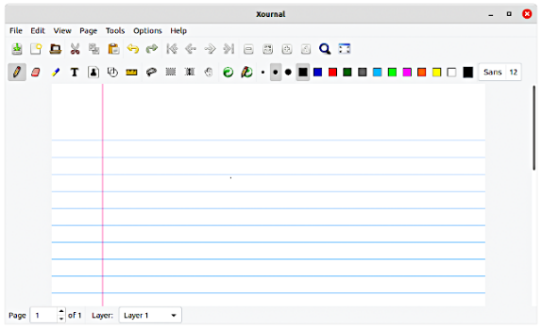
Figure 1. Xournal Opening Screen.

The menu bar (at the top) has file tools and settings. It duplicates many tools in the toolbars but with text labels instead of icons. The toolbars let you select the operation (line drawing, highlighting, erasing, inserting, and deleting objects), choose the colors, and designate areas for other functions. You have similar tools in your word processor and graphics software, making the tool easy to use.

Figure 2 shows the results of importing a logo, adding a line drawing and handwriting, importing text, and highlighting a portion of it.

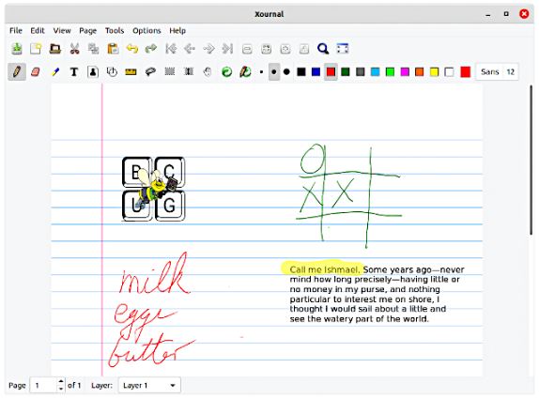
Figure 2. Example.

Xournal saves each note in a separate file, and keeping them organized requires effort. You should use descriptive filenames, place them in logical directories, and delete them when no longer needed. It would be easy to scatter dozens of notes throughout the hundreds of directories on most PCs. If you can’t find a note, it’s the same as if you’d deleted it.

I frequently use PDF files, often as articles I download or documents I receive. While these are convenient, they are difficult to modify. For example, when I download an article, I like to add the URL where I found it. Also, some PDF documents are questionnaires or require a signature. Xournal can use a PDF as a background, over which you can add text or sketches. Figure 3 shows an example.

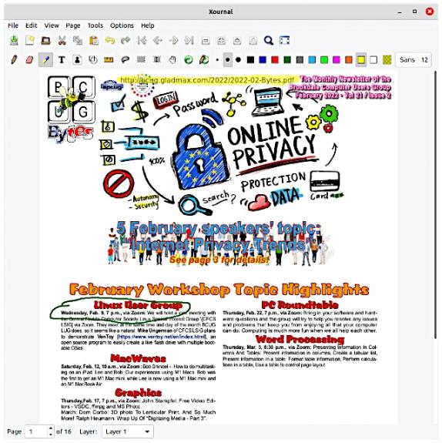
Figure 3. Modified PDF Document.

I’ve inserted (and highlighted) the document’s URL at the top and circled a meeting here. The original PDF hasn’t changed, but you can export the annotated result as a new PDF. This technique makes adding a signature far more convenient than my old PDF printing method, signing the paper copy, and scanning the result. You can use other graphics, and screenshots, for example, and annotate them. Do read the manual before doing this, as there are some subtleties.

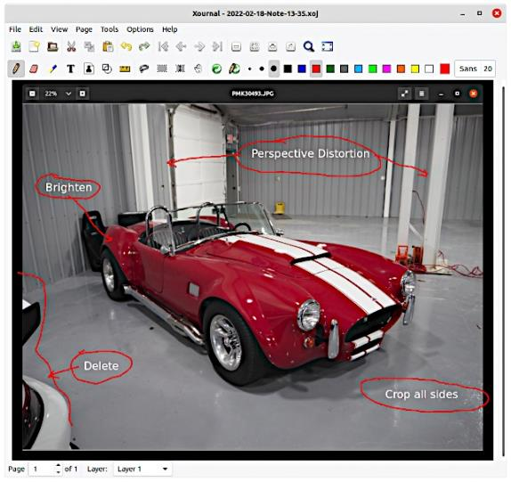
Figure 4. Annotated Photo.

Figure 4 shows another annotation example, this time of a photograph. It takes only a few minutes for an editor to show a photographer what changes are needed clearly. Here, the background image is a screenshot of the image viewer displaying the photo. Xournal can save files only as PDFs or in Xournal format. For this example, the editor would probably send his comments to the photographer as a PDF.

Choosing a notes tool for collaboration means considering what file formats it can use. PDF is the standard for documents, as are JPEG and PNG for images. If the tool can’t import the file directly, it may have a convenient workaround. For example, Xournal can import the contents of any window, so you can open an image file with your image viewer and allow Xournal to import it as a screenshot. Then, after annotating it, you can export it as a PDF.

For me, Xournal is most useful for annotation, particularly as an aid to collaboration. Team members frequently exchange documents or graphics; annotating them is far clearer than sending back printed comments. Of course, I prefer a text notes program when developing articles like this, but if you long for the Post-It days, you might like the Xournal approach.

